Case File Report
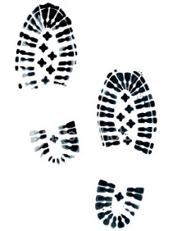
Directions: Use the spaces below to record any important clues you hear during your investigation and to do any mathematical computation that may help you solve the mystery.

Mr. Chang

Suspect 2

Suspect 1

Suspect 3

